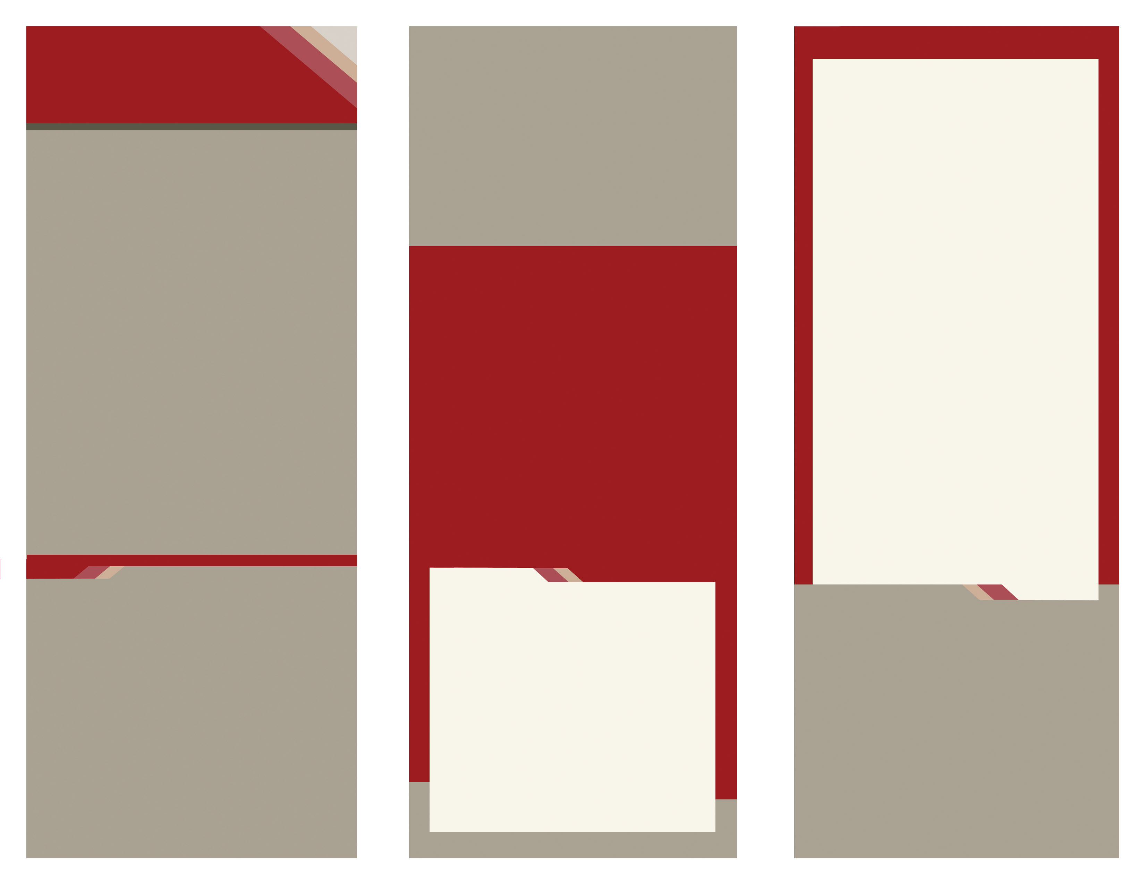
(217) 357-NOTE
132 N 5th Street
Quincy, IL
62301

www.CenterStageMusicSchool.com


Music & Performing Arts School

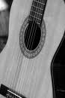

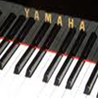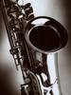


Enter Contact Information Here | 1127 Lombard Blvd. San Francisco, CA 59802 | phone 555.555.5555 | fax 555.555.5555
Center Stage Music will be open for business in August!

We are now enrolling for classes!

We would love to answer your questions!

Please call us at

(217) 357-NOTE

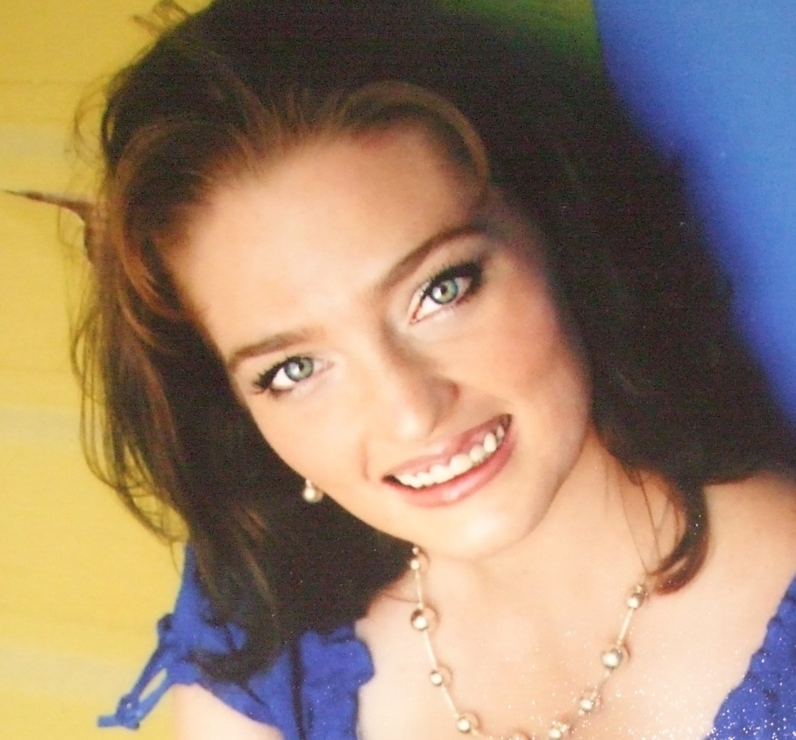
df

Co-Founder/Artistic Director
Chenille has performed for
audiences far and wide
including: Las Vegas, Mexico,
Disney Land, and Carnival
Cruise Line. She recently released a CD with world renowned concert pianist Marvin Goldstein.
Chenille has carried her love of singing and performing into teaching. Before moving to Illinois
she worked with the largest privately owned music school in the nation. She and her husband, Matt,
look forward to working with the talented people of Quincy!

For more about Chenille Saunders, visit her professional website at www.ChenilleSaunders.com

Center Stage Music School
Quincy, IL 62301

217-357-NOTE
www.CenterStageMusicSchool.com

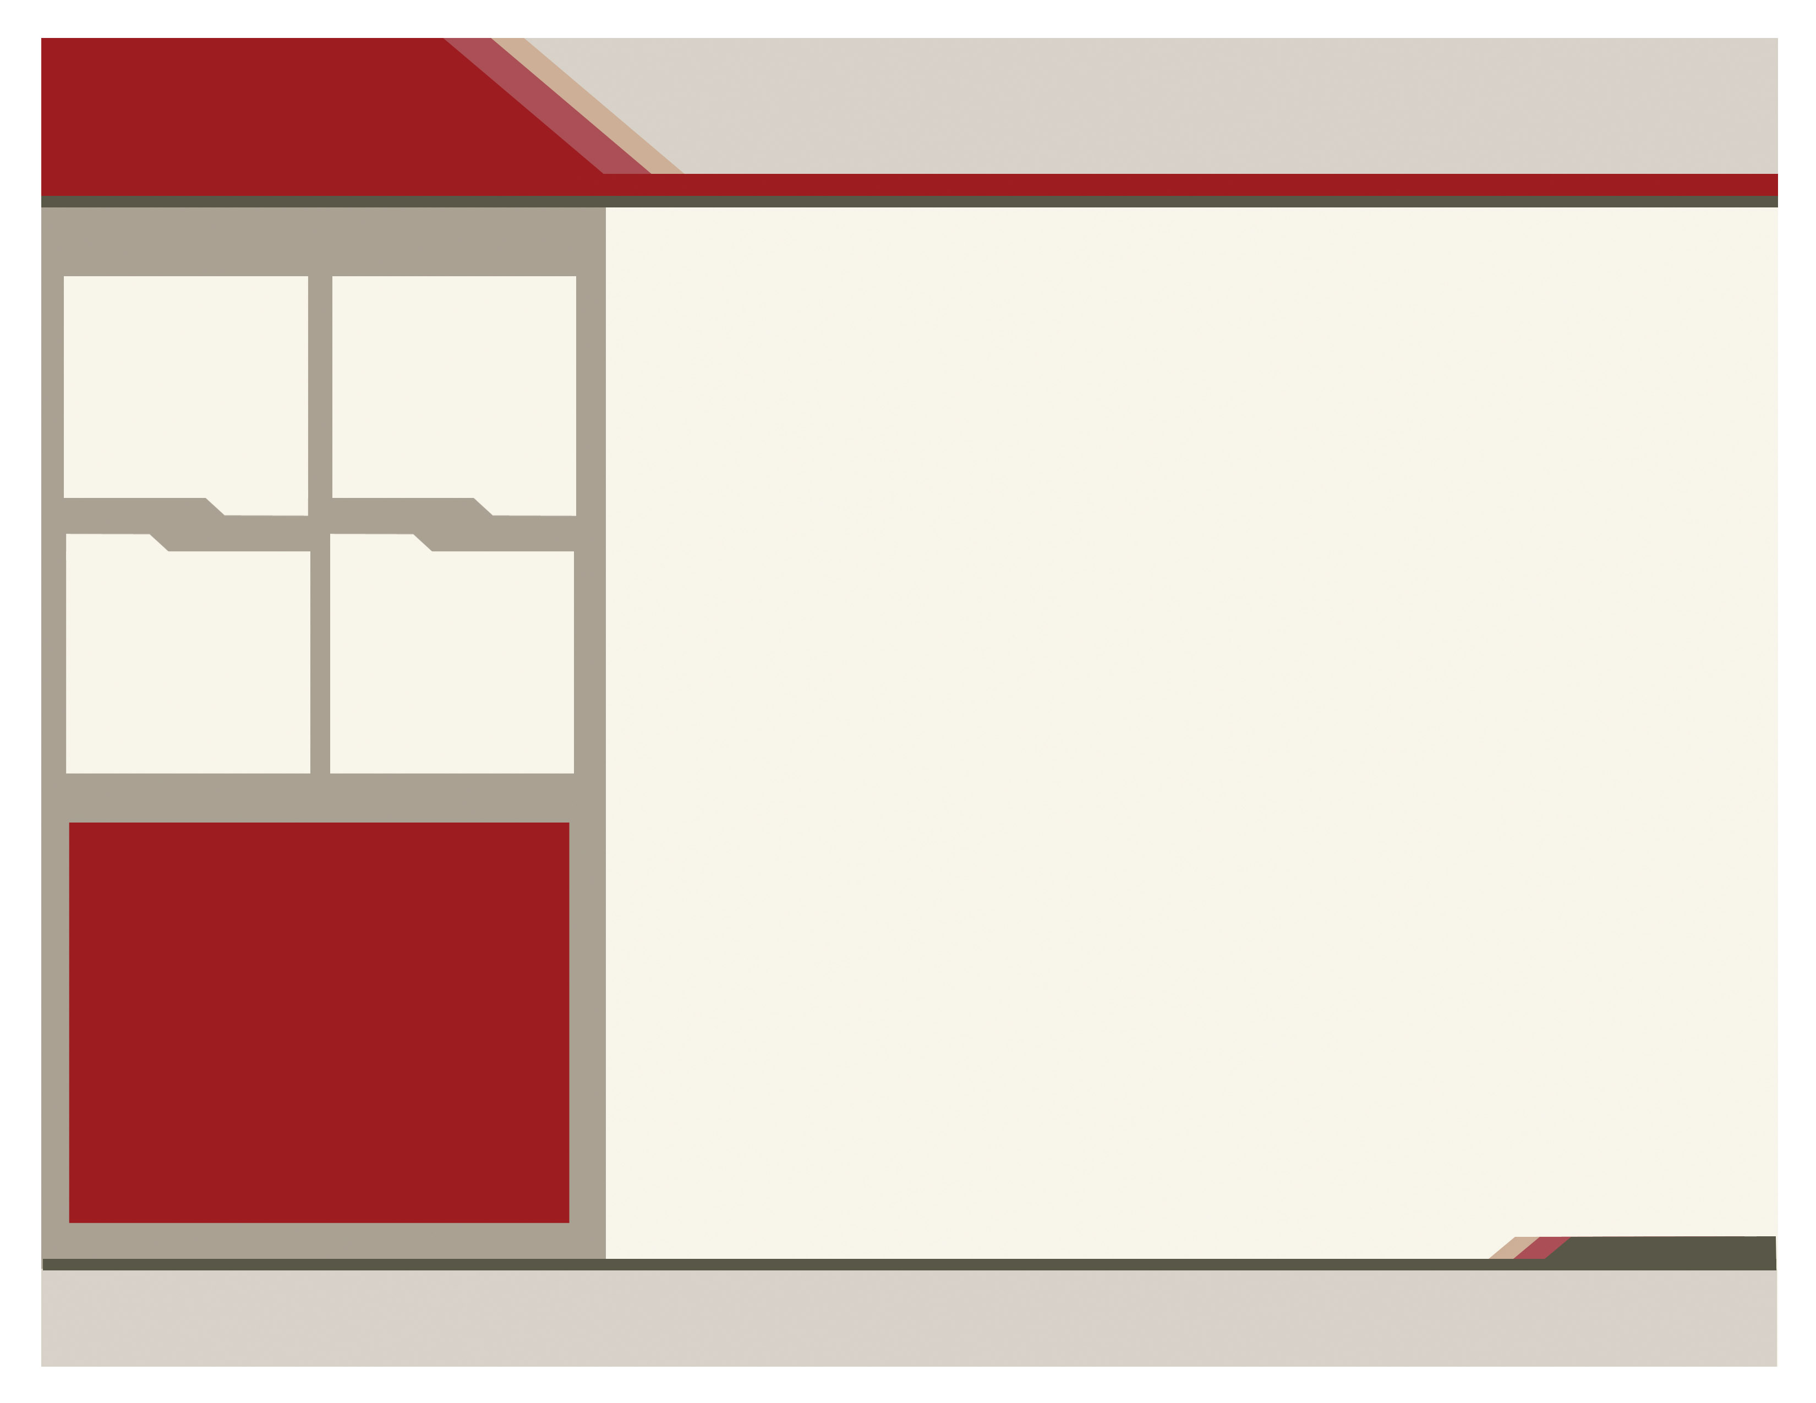
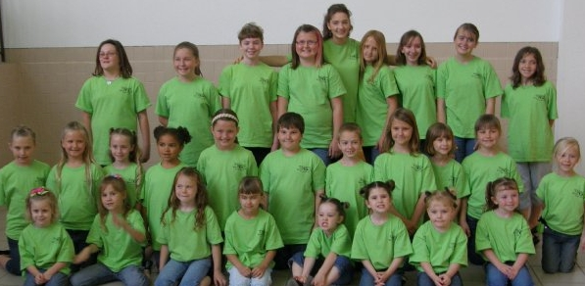

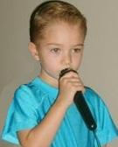
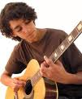
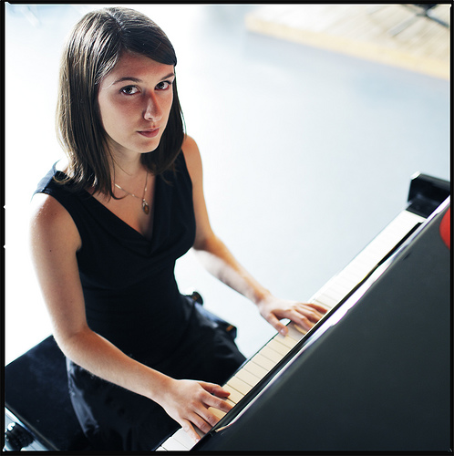

Center Stage Performers
Youth Performing Group
(Ages 3-18)

Classes Include:
Vocal Solos Speaking parts Theory Mic work Dance Drama/Improv Showmanship Rhythm
Self-esteem & MORE!

Classes Ages
Little Notes (3-5)
Applause (6-8)
Encore (9-12)
Prestige (13-15)
*The Elite (13-18)

“Center Stage Performers” season runs
for 4 months year round
Month 1- Voice
Month 2- Dance
Month 3- Drama
Month 4- Perform
Performances FREE to the public!

*Auditioned Touring Group

www.CenterStageMusicSchool.com

Private Study:
Private Voice- Voice fundamentals & Advanced Voice- Broadway/Musical Theatre- Classical Opera- Folk-Jazz/Blues-Inspirational Gospel- Ear Training

Private Piano/Keyboard- Fundamental & Advanced Piano-Classical- Inspirational/CCM/Gospel- Pop/Rock-Traditional Country- Modern Country-Improvisation/Ear-Accompanying

Private Guitar- Accoustic Guitar- Electric Guitar- Bass Guitar- Classical

Private Strings- Violin/Fiddle- Harp

Private Winds- Flute/Piccolo- Saxophone-Clarinet

Private Brass- Trumpet

Semi Private Classes:
Improv Troupe Mommy & Me Classes
Ballroom Dance Team Pageant Etiquette Classes

Master Classes:

(Master Classes conducted by professional Artists, Musicians, Composers, Dancers, Actors, and Performers)

Piano Master Class Composition Master Class
Guitar Master Class Music Business Master Class
Hair/Make-up Master Class Voice Master Class
Stage Master Class Studio Recording Master Class
Music for TV/Film Production & Recording

Workshops/Seminar/Group Classes:

Musician Jam Session Auditioning Workshops
Piano Workshops Acting Camps
Songwriting Camps Promote your Music Camp
Vocal Workshops & More…

Registration and Enrollment
Contact us at
(217) 357-NOTE

Reasons To Choose Our Music Program:

Private
Piano
Private
Voice (10-Adult)
Improv
TRoupe (8-Adult)
Private Guitar
- Multiple Family Scheduling.
- Community Performances.
- Stage & Equipment to learn first hand.
- Professional Teachers.
- Large variety of classes.
- Taught the style you want to learn:
pop, rock, jazz, classical, etc.
- Optional low-pressure recitals.
- Master Classes conducted by Professionals.

(5-Adult)
(6-Adult)

